**2018 Leaving Cert Physics Paper (Ordinary Level)**

**2018 no.1**

An experiment was set up to verify Boyle’s law.

1. Draw a labelled diagram of the apparatus used in this experiment.

The table shows the measurements obtained during the experiment.

|  |  |  |  |  |  |  |
| --- | --- | --- | --- | --- | --- | --- |
| *V* (cm3) | 2 | 3 | 4 | 5 | 6 | 9 |
| *p* (kPa) | 535 | 350 | 270 | 215 | 180 | 120 |
| 1*/V* (cm-3) |  |  |  |  |  |  |

1. How were the pressure and volume measured?
2. Copy and complete the table.
3. Explain how the data can be used to verify Boyle’s law.
4. State two precautions which the student might have taken to improve the accuracy of this experiment.

**2018 no.2**

An experiment was set up to establish the calibration curve of a thermometer.

1. Draw a labelled diagram of the apparatus used in this experiment.
2. What measurements were taken during this experiment?

The table shows the data recorded during the experiment.

|  |  |  |  |  |  |  |
| --- | --- | --- | --- | --- | --- | --- |
| Temperature/°C | 0 | 20 | 40 | 60 | 80 | 100 |
| Value of thermometric property | 10 | 25 | 60 | 100 | 160 | 200 |

1. Use the data in the table to draw a graph, on graph paper, to establish the calibration curve.

Put temperature on the horizontal (X) axis.

1. Use your graph to determine the temperature when the value of the thermometric property is 75.

**2018 no.3**

An experiment was set up to investigate how the fundamental frequency of a stretched string varied with its length.

The length *l* and the frequency *f* of the string were recorded.

1. Draw a labelled diagram of the apparatus used in this experiment.
2. Indicate on your diagram the length of the string that was measured.
3. Describe how the string was set vibrating.
4. How was the frequency of the string determined?
5. Sketch a graph to show the relationship between *l* and *f* that you would expect to obtain.

**2018 no.**4.

An experiment was set up to find the resistivity of the material of a wire.

1. Draw a labelled diagram of the apparatus used in this experiment.
2. What measurements were taken during this experiment?
3. How were these measurements used to calculate the resistivity?
4. State two precautions which the student might have taken to improve the accuracy of this experiment.

**2018 no.5**

1. 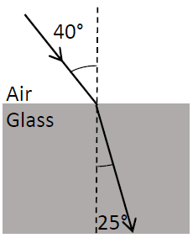State Newton’s first law of motion.
2. Calculate the refractive index of the glass block shown in the diagram.
3. Choose from the list below the instrument used to measure (i) energy and (ii) resistance.

barometer joulemeter lens ohmmeter

1. State one use for a semiconductor diode.
2. State one use for the instrument shown.
3. Define capacitance.
4. State two characteristics of a musical note.
5. Sketch the magnetic field around a bar magnet.
6. Name two sources of ionising radiation.
7. State one application of the photoelectric effect.

**2018 no.6**

1. Define momentum.
2. Define kinetic energy.
3. The cannon recoils when a cannon ball is shot from it.

Use the principle of conservation of momentum to explain why the cannon recoils.

Bumper car A of mass 500 kg is moving with a speed of 6 m s−1 when it collides with stationary bumper car B of mass 300 kg. After the collision the cars move together.

1. Calculate the momentum of each car before the collision.
2. What is the momentum of the combined cars after the collision?
3. Calculate the speed of the two cars after the collision.
4. Calculate the kinetic energy of each car before the collision.
5. Calculate the kinetic energy of the cars after the collision.
6. What conclusion can be drawn from the change in kinetic energy that happens during the collision?

**2018 no.7**

The temperature of an object can be measured using a thermometer.

1. What is heat?
2. What is meant by the temperature of an object?
3. What is the unit of temperature on the SI scale?
4. Express 20 °C in the units you have named in part (iii).
5. The diagram shows an apparatus used to compare heat transfer in different metals.

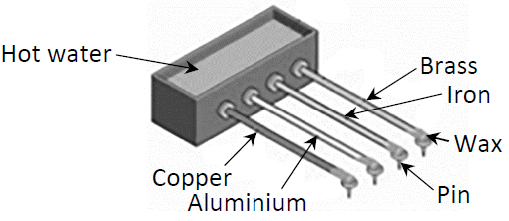

1. Name the method by which heat is transferred in metals.
2. Name the two other methods of heat transfer.
3. How can this experiment be used to find out which metal is the best at allowing heat transfer?
4. State two ways of making sure that this investigation is fair.
5. Metals are good conductors. Name a good insulator.

**2018 no.8**

Diffraction and interference are properties associated with waves.

* 1. Explain the underlined terms.
  2. Describe an experiment to demonstrate the wave nature of light.

The photograph shows a liquid crystal display (LCD) monitor, which may require a polaroid panel to allow the image on the screen to be seen clearly.



* 1. What is meant by polarisation?
  2. Describe an experiment to demonstrate the polarisation of light.
  3. Monitors of the kind shown use only three colours to form any image.

What three colours are used?

* 1. Describe how these colours can be used to create any image.

**2018 no.9**

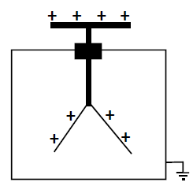**(a)**

The diagram shows a positively charged gold leaf electroscope.

* 1. State Coulomb’s law of force between charges.
  2. State one use of an electroscope.
  3. How can an electroscope be given a positive charge?
  4. What is observed when the cap of a charged electroscope is earthed?
  5. Explain this observation.
  6. How could the cap of the electroscope be earthed?

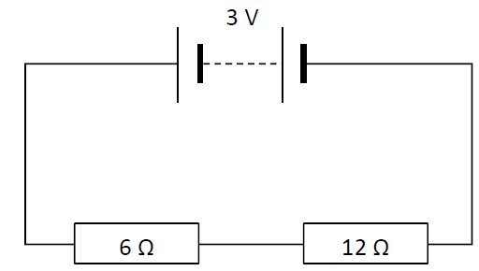**(b)**

The circuit diagram shows two resistors connected in series with a 3 V battery.

(i) State Ohm’s law.

(ii) Calculate the total resistance of the circuit.

(iii) Calculate the current in the circuit.

(iv) Calculate the potential difference across the 6 Ω resistor.

1. Name an instrument used to measure potential difference.

**2018 no.10**

X‐rays are produced when a beam of high speed electrons collides with a target in a tube like the one shown.

* 1. 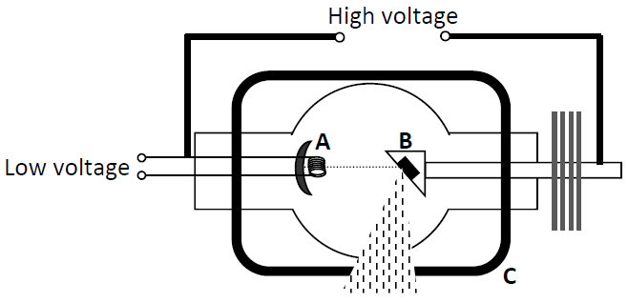What are X‐rays? State two properties of X‐rays.
  2. What process occurs at part A?
  3. Name a substance used in part B.
  4. State the function of part C.
  5. State one use of X‐rays.
  6. Why is a vacuum needed inside an X‐ray tube?
  7. Name another device that uses a beam of high speed electrons.
  8. State one use for the device you have named in part (vii).
  9. State one difference between X‐rays and gamma‐rays.

**2018 no.11**

Read the following passage and answer the questions below.

The Physics of Surfing

Many people are surprised to learn that there is a lot of physics involved in riding a wave.

Consider the principle of the wave itself: the energy of offshore storms is transmitted in ocean waves. As the ocean waves move into shallow water they slow down, the wavelength decreases and the wave height (amplitude) increases until the wave becomes unstable and breaks.

A vital physical principle behind surfing is Archimedes' principle, which keeps the board floating and allows the surfer to ride the wave. Archimedes' principle states that when a body is floating in a fluid it displaces its own weight of the fluid. The buoyancy (upthrust) counterbalances the weight of both the surfboard and the surfer and prevents both from sinking. Since the weight of the surfer is distributed evenly by the surfboard and is counterbalanced by the board's buoyancy, the surfer can stand on the top of the water.

The weight of the surfer on the board produces a force that is straight down. At the same time, buoyancy produces a force that acts on the board. This force, together with forces due to the wave, pushes the surfer forward. The sum of these forces results in a forward force that propels the surfer in the same direction as the wave.

Adapted from http://illumin.usc.edu/index/article/193/the‐engineering‐behind‐surfing/ (University of Southern California)

* + 1. What physical quantity is transmitted in a wave?
    2. Why do waves break close to the shore?
    3. Draw a diagram to show the main features of a wave.
    4. State Archimedes' principle.
    5. What is meant by the term buoyancy (upthrust)?
    6. How does buoyancy help the surfer to stay afloat?
    7. Draw a labelled diagram to show the forces acting on a floating object.
    8. Explain how the stance of the surfer shown helps her to balance.

**2018 no.12**

Answer any two of the following parts (a), (b), (c), (d).

**(a)**

1. Define velocity.
2. Define acceleration.
3. A train left a station and accelerated from rest at 0.4 m s−2 to reach its top speed of 55 m s−1.   
   The train then travelled for 300 seconds at this speed.
4. Calculate how long it took the train to reach its top speed.
5. How far did the train travel while at its top speed?
6. Draw a velocity‐time graph of the train’s journey.

**(b)**

Sunlight is made up of visible light of different colours as well as many types of invisible radiation.

* 1. How could you show the different colours present in visible light?
  2. UV radiation is also present in sunlight.

What do the letters U and V stand for?

* 1. Compare the wavelength of UV radiation to the wavelength of infra‐red (IR) radiation.
  2. Describe how to detect UV radiation.
  3. State one use of UV radiation.

**(c)**

The diagram shows a water boiler which is filled with 0.7 kg of water which is initially at 20 0C.

The boiler has a power rating of 3 kW.

* 1. Calculate the energy needed to raise the temperature of the water from 20 0C to 90 0C.
  2. How many joules of energy are supplied per second by the boiler?
  3. Calculate how long it will take the boiler to heat the water to 90 0C.
  4. Where should the manufacturer place the heating element of the boiler? Explain your answer.

(specific heat capacity of water = 4200 J kg−1 K−1)

**(d)**

1. What is electromagnetic induction?
2. Explain how you would use a magnet and a coil, as shown above, to produce electricity.
3. How would you know that electricity is being produced?
4. How could you increase the magnitude of the electricity produced?
5. The apparatus in the diagram can be used to produce a.c. electricity.

What is meant by a.c.?